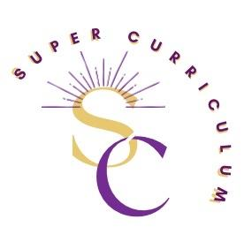
Psychology Department
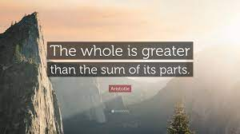
Super Curriculum

Reading
Title by Authors Name
Lillenfield,S.O, Lynn,S.J, Ruscio,J & Beyerstein, B.L  50 Great Myths of Popular Psychology  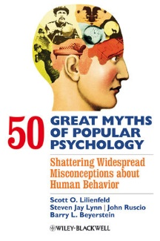 | Donaldson,M  Childrens’ Minds  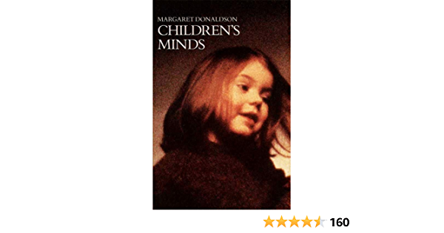
Bly,N  Ten days in a Madhouse | Britton, P  The Jigsaw Man
Podcasts
PsychCrunch (BPS) –  A podcast from the British Psychological Association  https://www.bps.org.uk/collections/psychcrunch  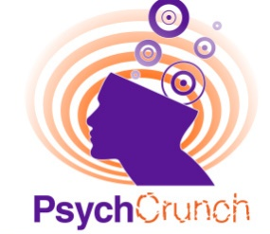  Explores whether the findings from psychological science can make a difference in real life. | In Our Time (BBC)  https://www.bbc.co.uk/programmes/p00546xr  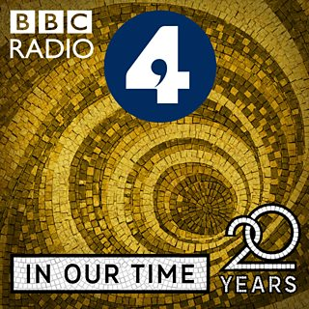  Explores the basis for evolutionary psychology and its development as a discipline.
The Hidden Brain  https://www.npr.org/series/423302056/hidden-brain  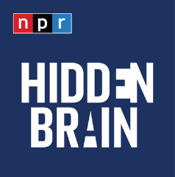  Discussion about laughter with neuroscientist Sophie Scott. | Brain Science  https://brainsciencepodcast.com/  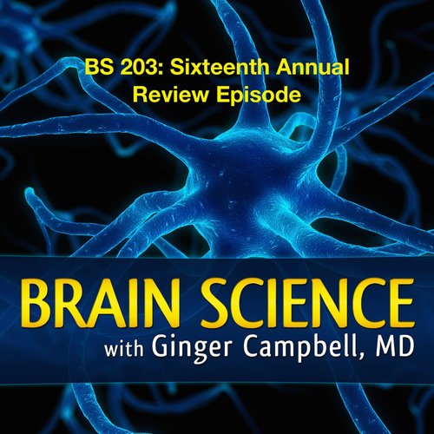  Exploring how recent discoveries in neuroscience are unravelling the mystery of how our brain makes us human.
TED Talks These interesting TED talks are a quick insight into some fascinating topics in Psychology

10 myths about psychology, debunked
https://www.ted.com/talks/ben_ambridge_9_myths_about_psychology_debunked
How much of what you think about your brain is actually wrong? In this whistle stop tour of dis-proved science, Ben Ambridge walks through 10 popular ideas about psychology that have been proven wrong — and uncovers a few surprising truths about how our brains really work.

How reliable is your memory?
https://www.ted.com/talks/elizabeth_loftus_how_reliable_is_your_memory?language=en
Psychologist Elizabeth Loftus studies memories. More precisely, she studies false memories, when people either remember things that didn't happen or remember them differently from the way they really were.

What do babies think?
https://www.ted.com/talks/alison_gopnik_what_do_babies_think
Alison Gopnik explores the sophisticated intelligence-gathering and decision-making that babies are really doing when they play.

The most important lesson from 83,000 brain scans
https://www.youtube.com/watch?v=Xrv_L8KkK7A
Daniel Gregory Amen is a famous psychiatrist who specializes in brain disorders. In his TED talk, he talks about the most important lesson we can learn from 83,000 different brain scans.

The mysterious workings of the teenage brain
https://ed.ted.com/lessons/the-mysterious-workings-of-the-adolescent-brain-sarah-jayne-blakemore
Cognitive neuroscientist Sarah-Jayne Blakemore compares the prefrontal cortex in adolescents to that of adults, to show us how typically “teenage” behaviour is caused by the growing and developing brain, in this TED Talk.

Strange answers to the psychopath test
https://www.ted.com/talks/jon_ronson_strange_answers_to_the_psychopath_test?language=en
Is there a definitive line that divides crazy from sane? Jon Ronson, author of The Psychopath Test, looks at the grey areas between the two.

Films
Shawshank Redemption  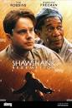 | Beautiful Mind  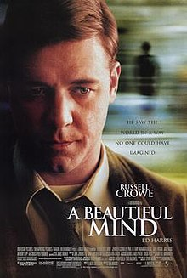
Rain Man  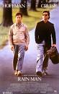 | The Experimenter  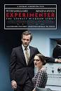
MOOCS
Most MOOCS are free and some are even accredited by prestigious Universities

Introduction to Psychology -Yale University
You must register for a free account with Courersa to take the course. There is no need to register for the paid-for course

https://www.coursera.org/learn/introduction-psychology

Futurelearn has thousands of online courses from top universities and specialist organisations however, SUBSCRIPTION IS REQUIRED

https://www.futurelearn.com/courses?filter_category=22&filter_course_type=unlimited&filter_availability=started
Membership and affiliations
Psychology Review
https://www.hoddereducation.co.uk/subjects/psychology/products/16-18/psychology-review
SUBSCRIPTION IS REQUIRED
Psychology Review magazine provides articles by experts in the field written specifically for A-level students, up-to-date discussion of research, and support for examination and maths skills.
Awards and Competitions  https://www.mindsunderground.com/oxbridge-competitions/overview | Oxford and Cambridge Essay Competitions  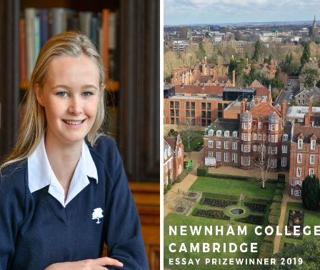
Places to Visit
The Freud Museum - Step into the world of Sigmund Freud and see his iconic couch.  20 Maresfield Gardens  NW3 5SX  Wed-Sun* 12-5pm (*open Mondays in the Summer)  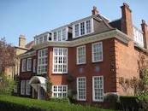 | The Museum of the Mind - The Bethlem Museum of the Mind records the lives and experience and celebrates the achievements of people with mental health problems.  Bethlem Royal Hospital, Monks Orchard Road, Beckenham, Kent BR3 3BX  Weds-Fri 10am-5pm  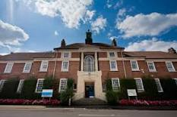
SHEPTON MALLET PRISON  Bethlem Frithfield Lane,  Shepton Mallet, Somerset BA4 5FQ  Mon-Sun 10am-5pm  Booking Required  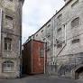 | Twycross Zoo -Go observe animal behaviours particularly those of our close relatives the bonobos and chimpanzees.  East Midland Zoological Society,  Burton Road,  Atherstone CV9 3PX  Mon-Sun 10am-5pm

