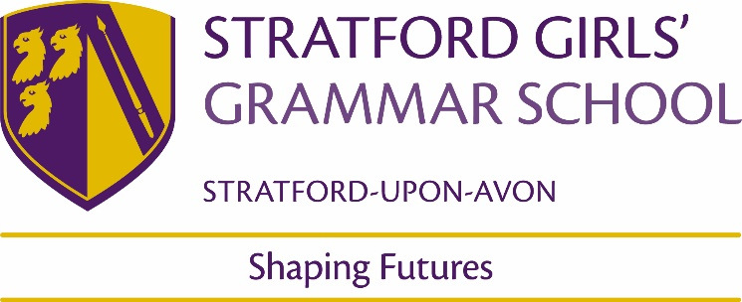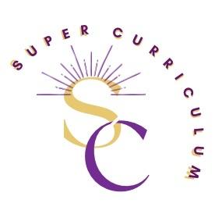

KS5 History Department
Super Curriculum
Reading (books and journals)
Title by Authors Name
- P.McPhee, Liberty or Death: The French Revolution  - L Moore, Liberty: The Lives and Times of Six Women in Revolutionary France  - R Scurr, Fatal Purity: Robespierre and the French Revolution  - S.Wahnich, In defence of the Terror: Liberty or Death in the French Revolution  - M Rapport, The Napoleonic Wars: A very short introduction  - W Doyle, Napoleon Bonaparte pocket Giants  - D Bell, Napoleon a concise Biography  - A Miller, Pure  - H Mantel, A place of greater safety  - T Keneally, Napoleon’s last island  - H Rubenhold, The French Lesson | - G R Elton, England Under the Tudors, Routledge, 1991  - A Fletcher & D MacCulloch, Tudor Rebellions, Longman, 2004  - Griffiths (ed), The Experience of Authority in Early Modern England, Macmillan, 1996  - S Gunn, Early Tudor Government, Macmillan,1995  - J Guy, Tudor England, OUP, 1998
Podcasts
- Revolutions https://open.spotify.com/show/05lvdf9T77KE6y4gyMGEsD
- Throughline https://www.npr.org/podcasts/510333/throughline
- The History Chicks (Yes, this is a real podcast) https://thehistorychicks.com/category/podcasts/
- Dan Snow’s History hit
https://www.historyhit.com/podcasts/
- Witness History
https://www.bbc.co.uk/programmes/p004t1hd/episodes/downloads
- 1619
https://www.nytimes.com/2020/01/23/podcasts/1619- podcast.html
- A History of the World in 100 objects
https://www.bbc.co.uk/programmes/b00nrtd2/episodes/downloads
- Stuff you missed in History class
https://open.spotify.com/show/4Zkj8TTa7XAZYI6aFetlec
- Dan Carlin’s Hardcore History
https://www.dancarlin.com/hardcore-history-series/
- Any of the podcasts on BBC History Extra website
https://www.historyextra.com/podcast/
MOOCs and on-line opportunities
- http://alphahistory.com/frenchrevolution/  - www.chnm.gmu.edu/revolution Images, documents and other resources relating to the French Revolution  - French Revolution Digital Archive (stanford.edu) Archive of text and images relating to the French Revolution  - Mark Steel - Vive La Revolution - YouTube https://www.youtube.com/watch?v=suZdYkZ_feM Terror Robespierre and the French Revolution  - https://www.youtube.com/watch?v=1oQp47OicfM The September Massacres and the Battle of Valmy | - www.johnguy.co.uk Articles on Tudor History  - www.history.ac.uk Institute of Historical Research  - www.activehistory.co.uk Educational games, simulations, quizzes etc  - www.bbc.co.uk/history Collection of BBC History programmes
Awards and competitions
- Holodomor essay prize https://www.augb.co.uk/holodomor/holodomor-essay-prizes
- John Locke institute essay prize https://www.johnlockeinstitute.com/essay-competition
- Newnham College – Woolf Prize https://newn.cam.ac.uk/admissions/access-and-outreach/woolf-essay-prize-2023/
- St.Hugh’s College – Julia Wood essay prize
https://www.st-hughs.ox.ac.uk/prospective- students/outreach-at-st-hughs/essay-competitions/julia-wood-history-essay-competition/
Places to visit
- People’s History Museum
- International Slavery Museum
- Black cultural archives
- Queer Britain Museum
- Black Country Living Museum
- Hay Festival
Membership and affiliations
Historical Association https://www.history.org.uk/

